HOMEWORK

TASK ONE: IN CLASS YOU LEARNT HOW TO SHOOT DEPTH OF FIELD. RESHOOT AT HOME BETTER IMAGES AND EDIT USING fotoflexer.com OR SIMILAR
Using your worksheet take 2 good images showing depth of field. Choose aperture priority and select a low f number (to create a soft background with an object in the foreground). You must also complete an image using a high f number. This will result in an image with a clear foreground and background.

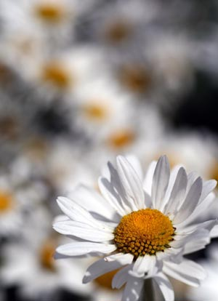
TASK TWO
Complete your critical study on relevant photographer and upload with the picture to your blog. See the art website yjbartdepartment.co.uk to download a crit sheet

TASK THREE: MACRO
Using the macro setting on your camera or a lense if you have one take a detailed close up image of a small object. This could be a flower/insect or other small object.

BLOGS
Update your blogs. Your new blogs need to have 4 new posts. I want you to use our yjb photography pinterest account to find artists related to your chosen topic. Write a critical study on the photographers work and upload to your account. Find 2 more similar photographers that link with your project and write a brief description of their work and how it ties in with your project.
Add another page to your account called ‘Techniques’. Add information about depth of field and your OWN images. Also add info about macro and upload your macro images. THESE MUST BE MORE EXCITING THAN THEY PRESENTLY ARE. ALL PAGES SHOULD NOW BE UP AND RUNNING. SEND YOUR LINKS TO yjbphotography@gmail.com

Fashion workshop
Look at the images on the yjb photography pinterest for inspiration. You need to bring with you costume / props and an image/photo to inspire you.

